Request for Reimbursement

Please use this form to request reimbursement for:
- Eligible expenses not covered by any health or dental insurance.
- The unpaid balance of a health or dental care claim submitted under an employee’s group plan.
- Dependent day care expenses.

Employee Name Social Security #

Telephone # (Work) Work Location:

Provider of Service | Person Receiving Service | Relationship to You (the employee) | Date Expense Incurred | Expense Type* | Reimbursement Request Amount
* Expense Type Code: M-Medical; H-Hearing; D-Dental; V-Vision;  P-Prescription Drug; C-Dependent Care |  | Total Reimbursement Requested |  |  | $

I certify that:
- The health and/or dental care expenses claimed above are not eligible for reimbursement by any insurance carrier or employer-sponsored health or dental care plan.
- The dependent day care expense claimed above enable me to be gainfully employed, are attributable to the care of a qualifying individual, and have not been paid to a dependent. I further certify that these dependent day care expenses submitted under this claim and when combined with dependent day care expenses reimbursed previously this year do not exceed my (or, if married, the lower of my or my spouse’s) earned income.
- The expenses claimed above have not been, and will not be, taken as a credit or deduction on my personal income tax return.
- Where I have not included the address and taxpayer identification number of each dependent day care provider listed above, I have done so because:
  - I submitted it earlier this year, or
  - The provider is a non-profit, religious, charitable or educational organization (under Section 501(c)(3)) or
  - I was unable to obtain this information after diligently trying to obtain it.

Date: Employee Signature:

For dependent day care expenses ONLY, send copies of records supporting each listed item of expense or have your Day Care Provider sign the statement below:

I provided the Day Care services as stated above Tax ID:

Date: Day Care Provider Signature:

See back for important instructions on completing this form.
Instructions for Completing Your Claim Form

Please read these directions before mailing your form. If this form is not completed correctly, your request will be returned.

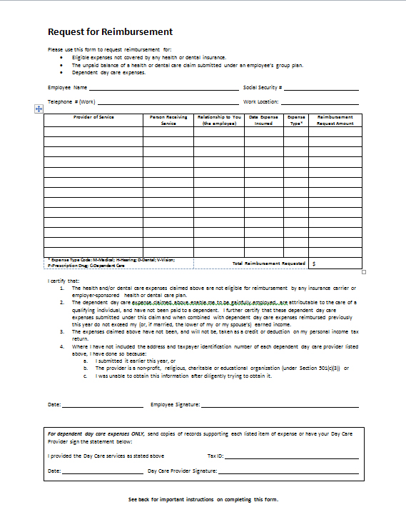
- In section “A,” fill in your name and social security number.
- Complete the following information in section “B::
  - Provider of Service: Enter the name of the person or facility that provided the service.
A
  - Person Receiving Service: Enter the name of the eligible person covered under the claim.
B
  - Relationship: If the claim is for you, enter “self”; if the claim is for a dependent, enter “spouse,” “child,” or “parent,” whichever is applicable.
  - Date Expense Incurred: Enter the date the service was provided (not the date of the bill).
C
  - Expense Type: Enter the code for the type of expense using the following:
D
M-Medical
D-Dental
P-Prescription Drugs
H-Hearing
V-Vision
C-Dependent Care
  - Reimbursement Amount: Enter the amount requested for reimbursement. (NOTE: if you have a Health Care Explanation of Benefits to attach, enter the difference between the amount paid by the health care plan.)
- In section “C,” be sure to date and sign the form or your claim will be delayed. No claims can be processed without a signature. If this is a dependent day care expense, complete the dependent day care expense information in section “D.”
- Documentation Needed: You must attach copies of required documentation to receive reimbursement. If documentation is not correct, the request will be returned to you.
  - For expenses covered by your insurance company or health care plan, attach a copy of the Explanation of Benefits (EOB) form received from the insurance company or administrator. For prescription drug expenses, submit a copy of the drug label.
  - For eligible medical expenses not covered by a health care plan, attach a statement of expense showing the type of service, the incurred date and the amount of expense: For example, a physician’s bill or itemized receipt.
  - Cancelled checks are not acceptable documentation.
- Submit completed and signed form (with documentation attached).

